Introduction to recursion
Submitted by: Bhuwanesh Nainwal

In this article you will introduced with fundamental concepts related to recursion.
What is recursion?
Recursion in programming is defined as the function that calls itself unless a particular condition (base condition) is met. The function being called is known as the recursive function.
myFunction(parameters) {
// Recursive call
myFunction(parameters)
}

Here, “myFunction()” is a recursive function.
For example, we want to print sum of n natural numbers where n is a positive integer. This problem can be solved by implementing the logic with recursion.
myFunction(n) {
// Recursive call
return n + myFunction(n - 1) // Statement 1
}
// From the main function
// Menu driver code
main() {
myFunction(n)
}

Description:
In the above pseudo code, from the main function we are calling a recursive function, “myFunction()” by passing a number, n as a parameter to the recursive function. This number represents upto which number we want to calculate the sum of natural numbers. Inside the myFunction(), statement 1 gets executed. In statement 1 we are adding the number n and recursively calling the function, “myFunction()” for a smaller value of n, i.e. calling myFunction(n - 1) and so on.

Need of base condition?
A base condition is required to stop the recursion and sometimes it also specifies the solution for a smaller problem using which we can solve a large problem. A recursive function having no base condition may lead to stack overflow. For example, In the above example we have not mentioned the base condition. Due to which the above program will stuck into infinite recursion and would result into stack overflow.
Can you guess what can be the base condition for the above program?
We want to stop the execution of recursion once we reach to the value of n equal to 1. For this value of n, the recursive function should return one.
We can modify the above program as,

myFunction(n) {
// Base condition
if n == 1:
return 1
// Recursive call
return n + myFunction(n - 1)
}
// main function
main() {
myFunction(n)
}

}

Now the recursive function would return one, once the value n gets reduced to one.

Visualization of the above program using state space tree for the value of n = 4:

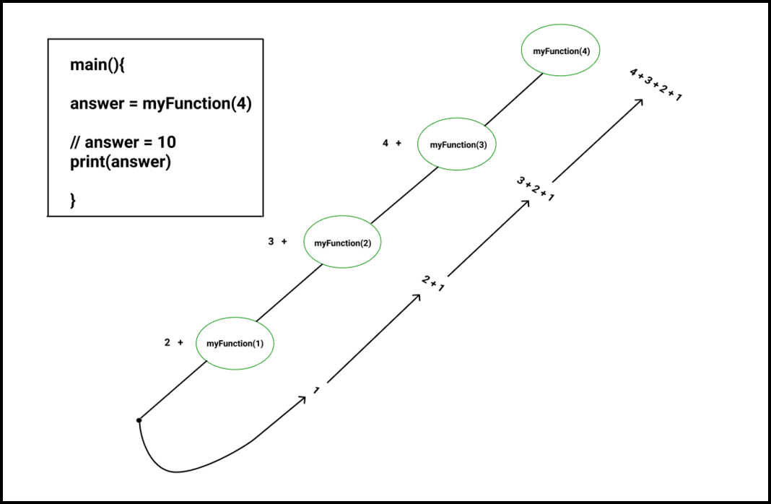

Types of recursion:
Recursion can be broadly divided into three categories. In the first category we concern about whether recursion uses a single or multiple functions to implement recursion that is, direct recursion or indirect recursion and in the second category we focus upon whether the recursive call occurs before executing other statements of the function or after the execution of other statements that is, head-recursion or tail-recursion. Third category is all about the number of times recursive call is made. These sub-categories are explained below in details.

1. On the basis of number of functions used:
- Direct recursion: In direct recursion, a function calls itself without the help of any other function. For example,
myFunction(parameter){

// Calling “myFunction” again
myFunction(parameter)
}

myFunction2(parameters) {

// Calling “myFunction1()” function inside the body of “myFunction2()” function
myFunction1(parameters);
}

In the above snippet only one function (i.e, “myfunction”) is involved to implement recursion.
- Indirect recursion: In indirect recursion, a function calls itself with the help of some other functions. For example,
myFunction1(parameter){

// Calling “myfunction2” function inside the body of “myFunction1”
myFunction2(parameter)
}

myFunction2(parameters) {

// Calling “myFunction1()” function inside the body of “myFunction2()” function
myFunction1(parameters);
}

In the above snippet, firstly the function “myFunction1()” has been called. Inside the “myFunction1()” we are calling “myFunction2()”. Inside “myFunction2()”, again myFunction1() is being called and so on.

2. On the basis of where the recursive call is used with respect to other statements:
- Head recursion: If there is no statement to be executed before the recursive calling statement then this technique of recursion is known as head recursion. For example,

myFunction(parameters){

// recursively calling myFunction
myFunction(arguments);

// other statements

}

- Tail recursion: If there is no statement to be executed after the recursive calling statement then it is known as tail recursion. For example,
myFunction(parameters){

// Other statements

// Recursively calling myFunction
myFunction(arguments);
}

3. On the basis of number of times a recursion call is made:
- Tree recursion: If a function calls itself more than one time then it is known as tree recursion.
For example,
myFunction(n){
if n < 6:
print (n)
// Recursive call
myFunction(n + 1)
// Recursive call to the same function again
myFunction(n + 1);
}
// Main function
Main(){
myFunction(1)
}

In the above snippet, we have made recursive call to the same function, “myFunction()” twice.

Memory used in recursion:
Recursion uses the system’s stack memory that is why recursive functions are also known as memory consuming functions. For example, while computing the sum of n natural numbers using recursion, During each time there is a recursive call a new activation record is created in the stack memory.
The memory diagram for computing sum of first four natural numbers using recursion is given,

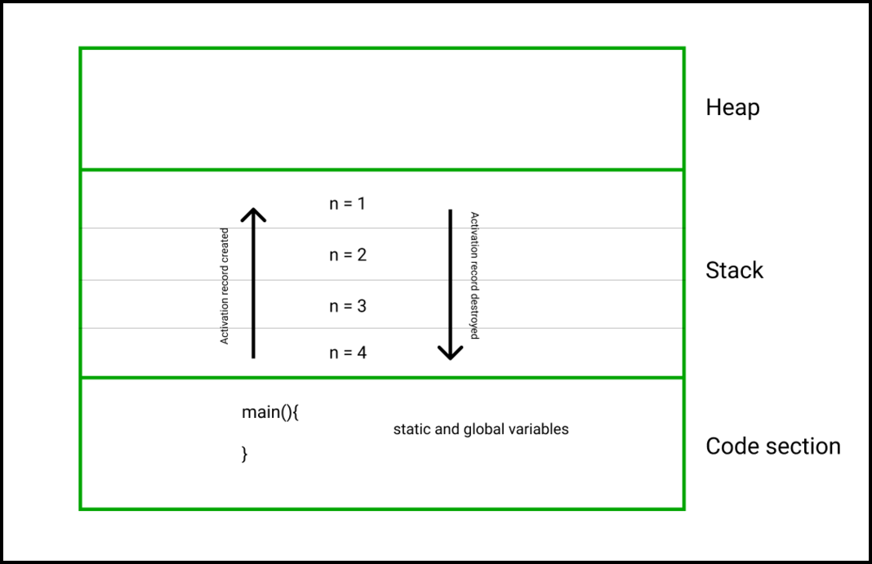

What is stack overflow?
Now we have understood that recursion uses the stack memory of the system. Sometimes due to deep recursion or infinite recursion there is not sufficient space available to store variables or information of the next recursive calls, this situation is known as stack overflow.

What is recurrence relation?
A recurrence is an equation or inequality that describes a recursive function in terms of the values on smaller inputs.
For example, Calculating sum of natural numbers.

The mathematical equation is given by,
1 if n == 1
myFunction(n) = n + myFunction(n - 1) otherwise

The recurrence relation is given by,
T(1) = 1 if n == 1
T(n) = n + T(n – 1) otherwise

Time complexity of recursive functions:
Time complexity is defined as the amount of time taken by an algorithm to do a particular task. Computing time complexity of recursive functions requires good knowledge mathematics and computation. There are three methods using which we can computer the time complexity of recursive functions,
1. Substitution method 2. Recursive tree method 3. Master method

Comparison between recursive and iterative approach:
Sr. No. | Recursive approach | Iterative approach
1. | Consumes more memory as for each function call a new activation record is created | Do not consume much memory space.
2. | Source code is sometimes complex. | Most of the time source code is easy to understand.
3. | Sometimes due to large number of recursion calls, the recursion may result into stack overflow. Hence, recursion is sometimes slower than the iterative approach. | As system’s stack is not used in iterative approach. Iterative approach is faster as compared to recursive approach
4. | Determining time complexity requires good knowledge of mathematical concepts like recurrence relation, Master theorem etc. | Time complexity can be easily determined.

Sample problem:
- Find the nth number of the Fibonacci series using recursion.
- Please try to solve this problem on your own before moving to the solution part.

Solution:
Fibonacci series or sequence is a famous series in the field of mathematics and computation. In a Fibonacci sequence each term of the sequence is equal to the sum of the previous two terms. First two terms are specified as 0 and 1.
To solve this problem, let us firstly determine the recurrence relation,
Fibonacci(n) = 0 if n = 0
Fibonacci(n) = 1 if n = 1
Fibonacci(n) = Fibonacci(n – 1) + Fibonacci(n - 2) otherwise

State space tree:
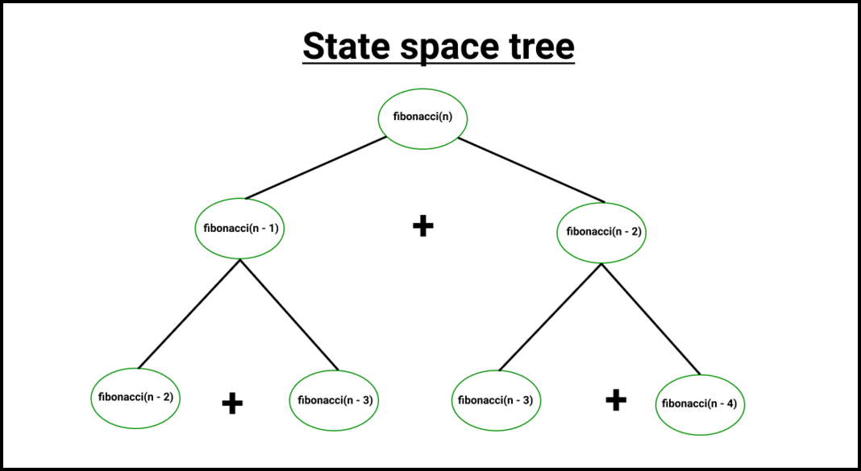

Identifying the base condition:
As it is clear from the recurrence relation that base condition occurs when n is either
equal to zero or one.

Below is the implementation in C++.
Source code link C++

Complexity analysis:
Time complexity: O(2^{N}) where N is a term of fibonacci series as for each value of n two recursive calls are made
Space complexity: O(2^{N}) where N is a term of fibonacci series as recursion uses system’s stack

